* **Create three instances, install nginx, and apply ALB**

First of all we should create one security group and that one security group is enough for the purpose of creating 3 instances. 3 instances should have 3 different available zones. The london region have 3 zones.

**Security group :**

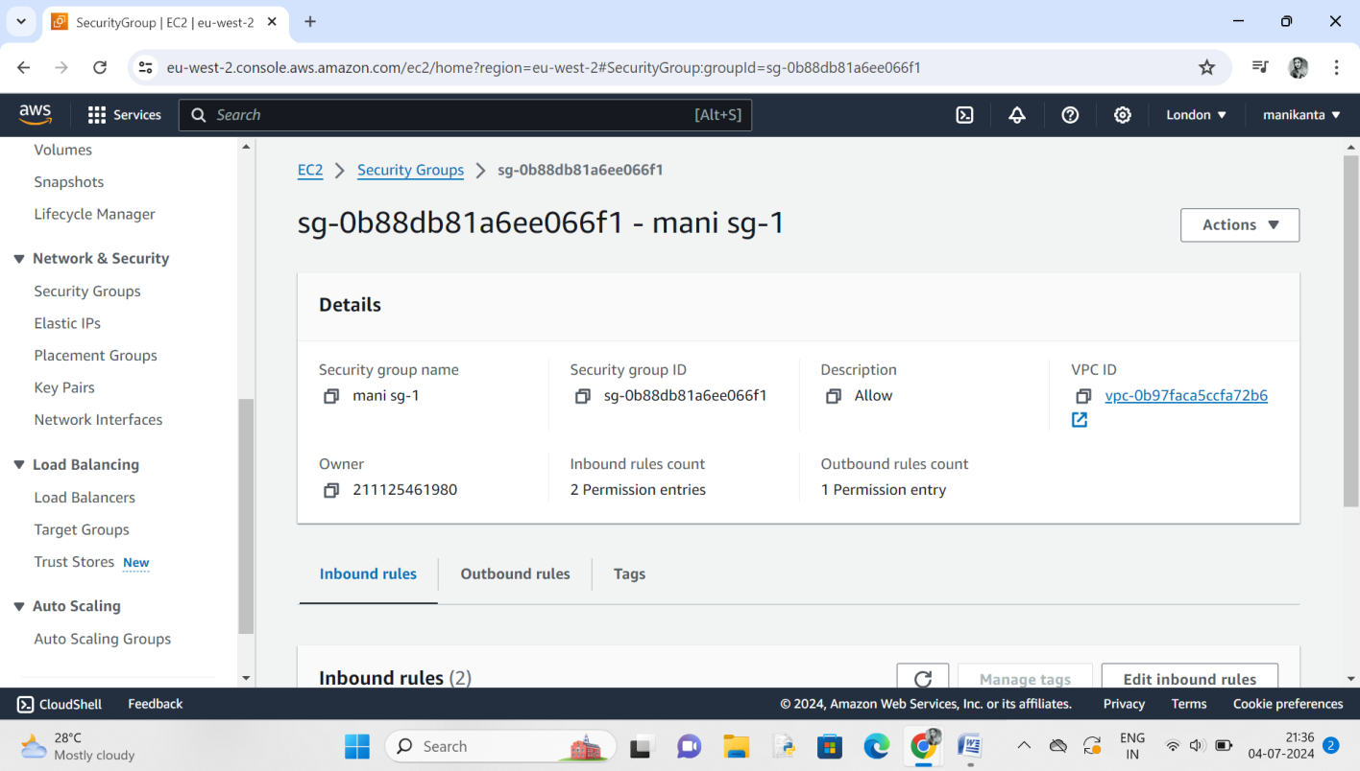

**Create 3 instances:**

Here we create 3 instances with same key pair and same security group

With 3 available zones each instance have different available zone. 3 instances used one vpc.

The followings pictures tells about that

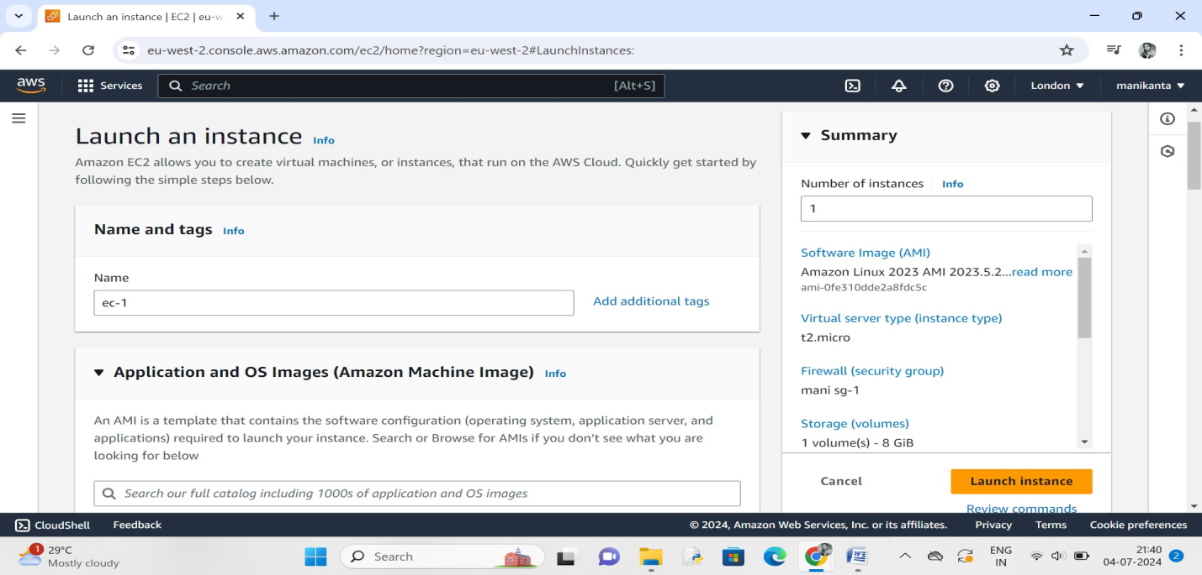

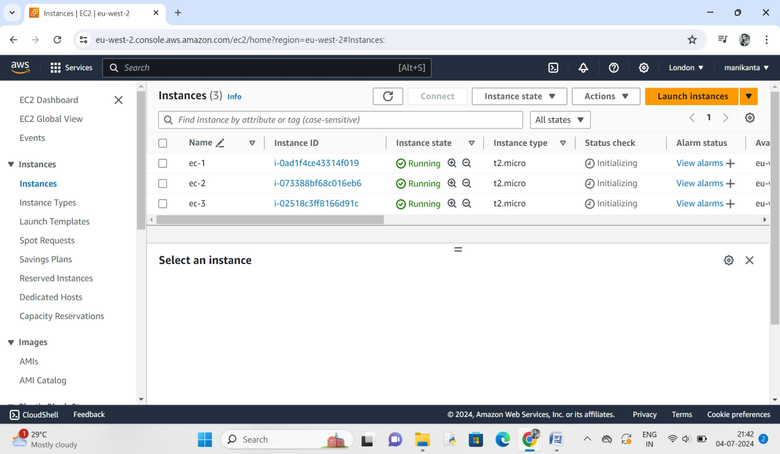

* After that we should connect the 3 instances into 3 servers
* Install nginx in the server

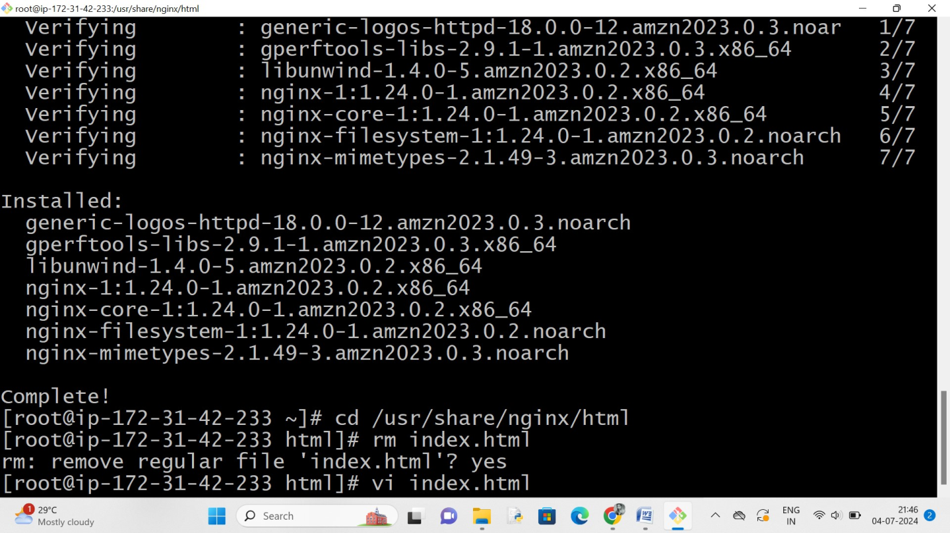

* Then check the public link with port number on browser

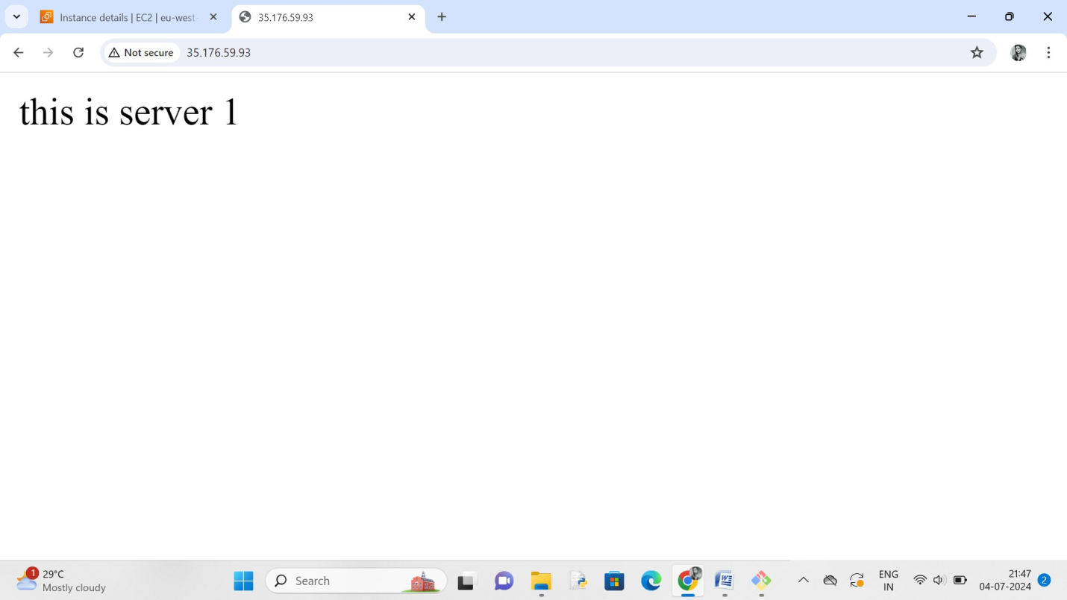

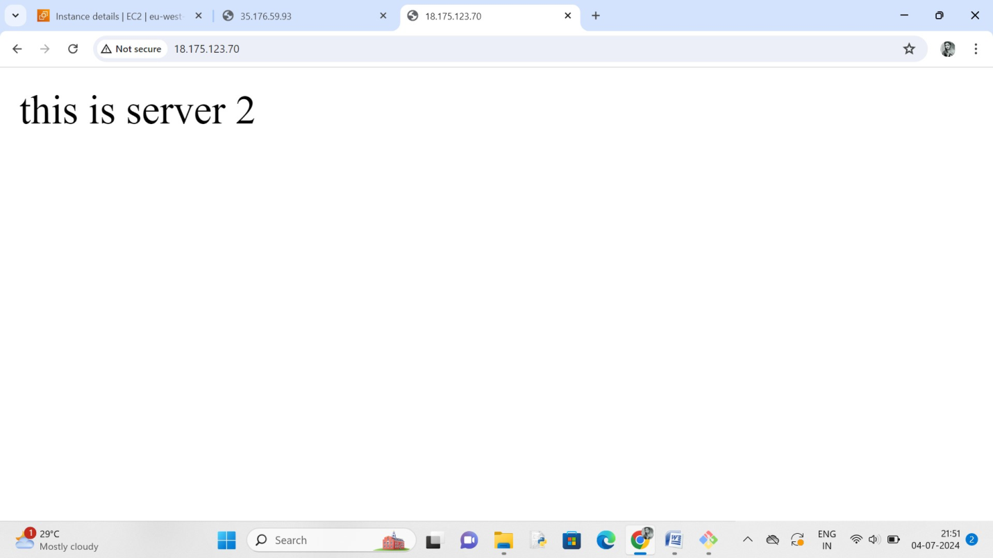

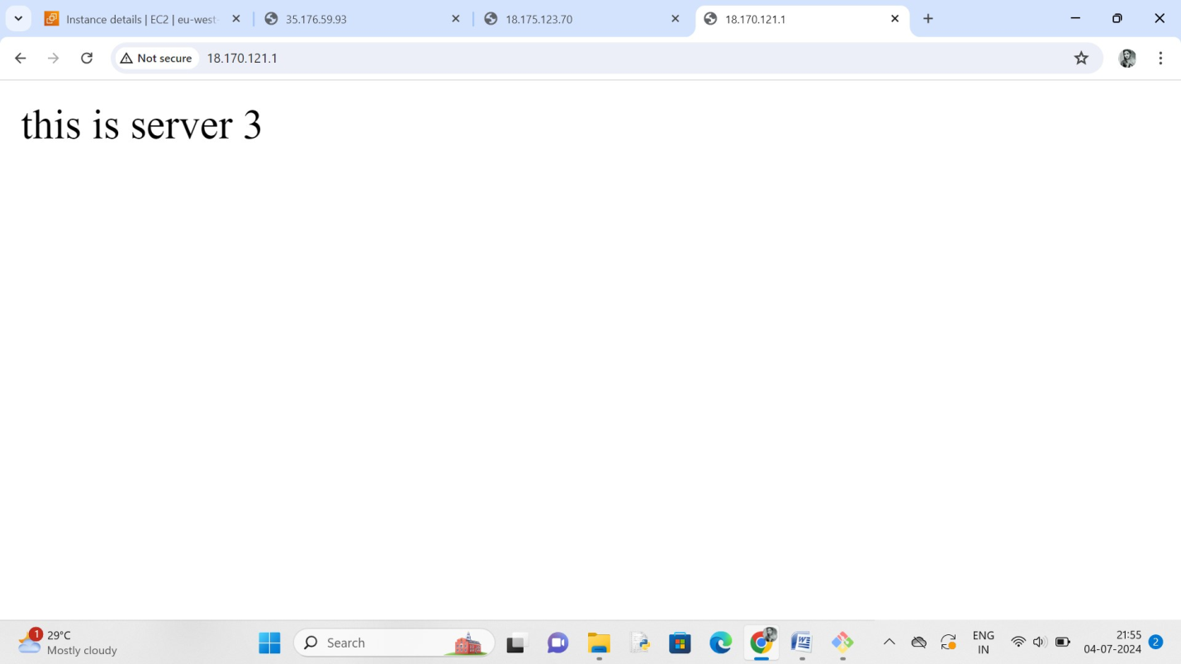

* After that we should create target groups and create load balances

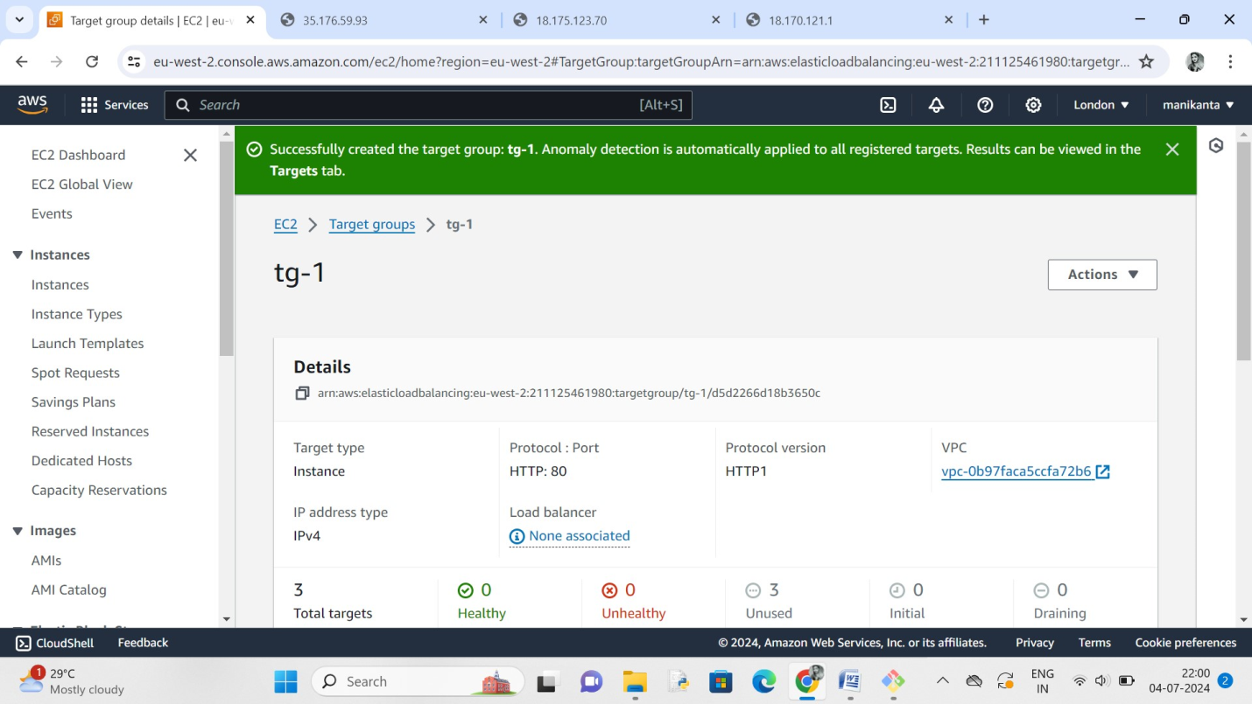

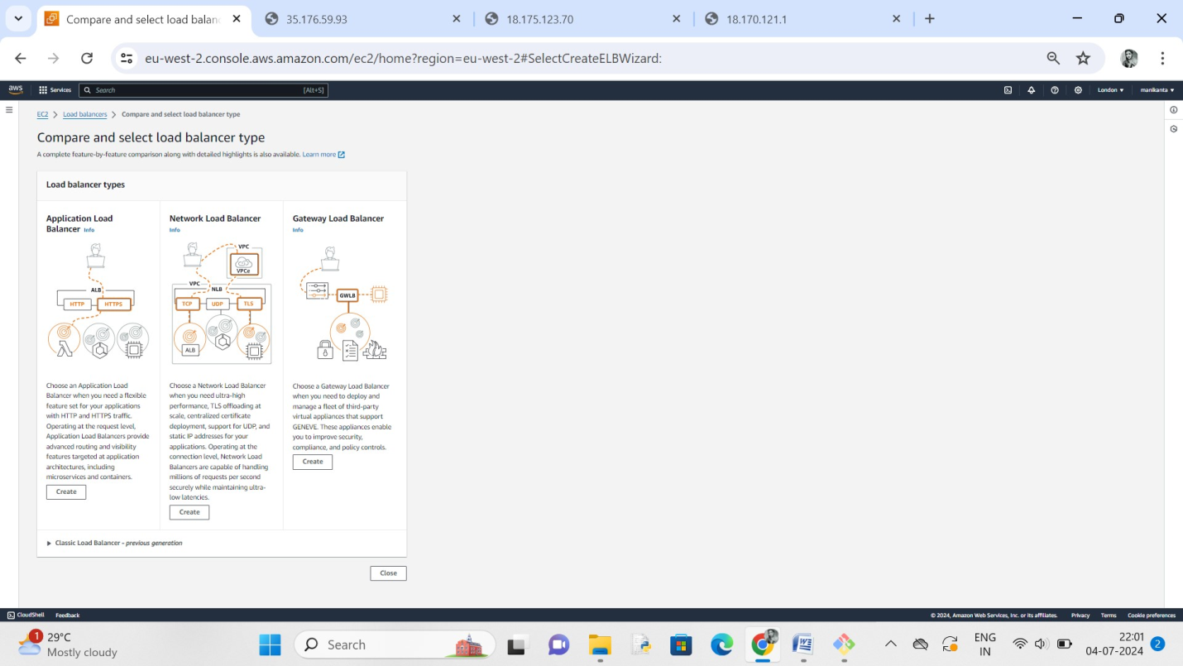

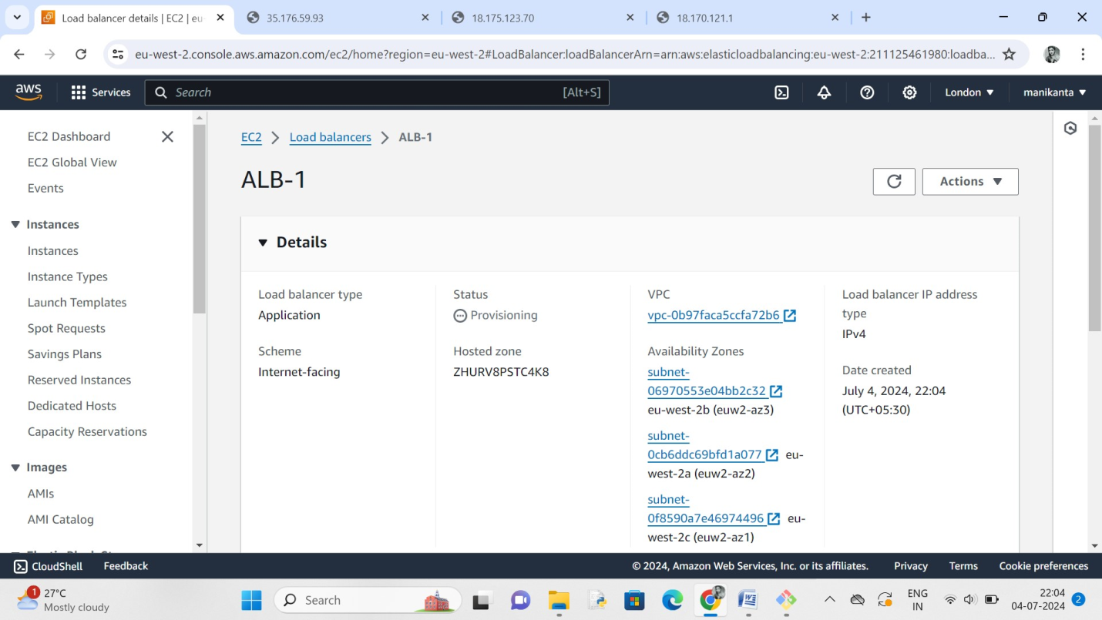

After the successful creation of load balances… we should copy the dns and paste on browser and checks the load balances

